Ansible Fork vs Serial:

<https://medium.com/devops-srilanka/difference-between-forks-and-serial-in-ansible-48677ebe3f36>

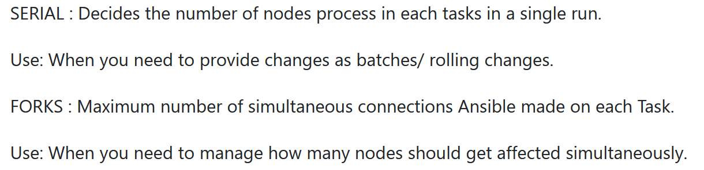

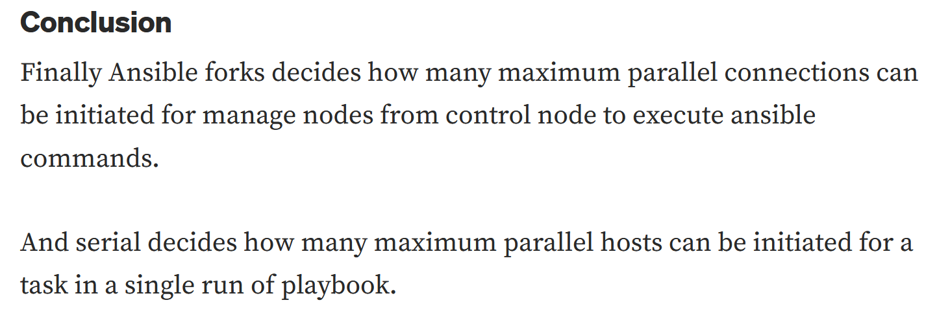

RAW vs SHELL vs Command:

<https://www.unixarena.com/2018/07/ansible-command-vs-shell-vs-raw-modules.html/>